Liverpool Students’ Union
Liverpool John Moores University

Democracy and Campaigns Coordinator

Recruitment Pack
July 2018

ABOUT LIVERPOOLSU

We are the Students’ Union for all students at Liverpool John Moores University. We’re a completely student-led organisation, independent from the University, here to welcome LJMU students to student life and ensure that they have the best possible experience whilst they’re here.

We do this by helping LJMU students succeed with their course and help them get their dream job when they leave.
We have an entire support service dedicated to making sure LJMU students achieve the best they can on their course. Whether it’s feedback on what’s good or what needs to be changed, or if they need some impartial advice, we’re here to help. You can find out more about this service here: liverpoolsu.com/represent

We can also provide a wide range of employability skills to set students up for when they leave. Students can volunteer with us in a range of positions or gain important employability skills in a range of positions on our student staff team (from positions working out in the community, to reception to digital content.)
Feel part of the student community.

Coming to university isn’t just about getting a great degree - it’s also where students grow and develop, make friends and try new things. LiverpoolSU is here to help make this easy for LJMU students.

We run over 105 clubs and societies for students to explore and join, so whether they’re playing football, baking or they want to meet other international students, there’s a student group for everyone. Find them here: liverpoolsu.com/groups

We want all students to know and love this city as much as we do, so we have a jam-packed calendar of events held in a range of venues across the city, from cinema nights to quizzes. We’ve partnered with the city’s biggest and best event organisers to give our students the full Liverpool experience.

You can keep an eye on our events here: liverpoolsu.com/events
Have a voice, and get it heard.

We’re the link to the university, which means if something needs to change, we’ll help make it happen. We have a simple online feedback tool where students can give feedback about anything and everything, 24/7, and we’ll make sure it goes to the right place.

Find out more here: liverpoolsu.com/thestudentvoice

Where we are:

You can find us across campus, so it doesn’t matter where you study, we’re always close by.

Our main base is at the John Foster Building on Mount Pleasant, where our Reception, Advice Centre and offices are, but we’re also in the social spaces at Byrom Street, Tithebarn Street, Redmonds Building and IM Marsh.

We are student-led – we’re run by a team of 4 Student Officers elected by LJMU students.
Each March the members vote for students who they wish to become elected officers at LiverpoolSU. Our current team are:
Angelina Cliff – President
Julia Daer – Vice President Academic Quality
Fiona Brereton – Vice President Activities
Howisha Penny – Vice President Community Engagement

You can read more about Liverpool Students’ Union at:
https://www.liverpoolsu.com/

Follow us on Facebook: facebook.com/LiverpoolSU
Twitter: Twitter.com/LiverpoolSU
Snapchat: LiverpoolSU
And Instagram: Instagram/LiverpoolSU

LIVERPOOLSU STAFF STRUCTURE
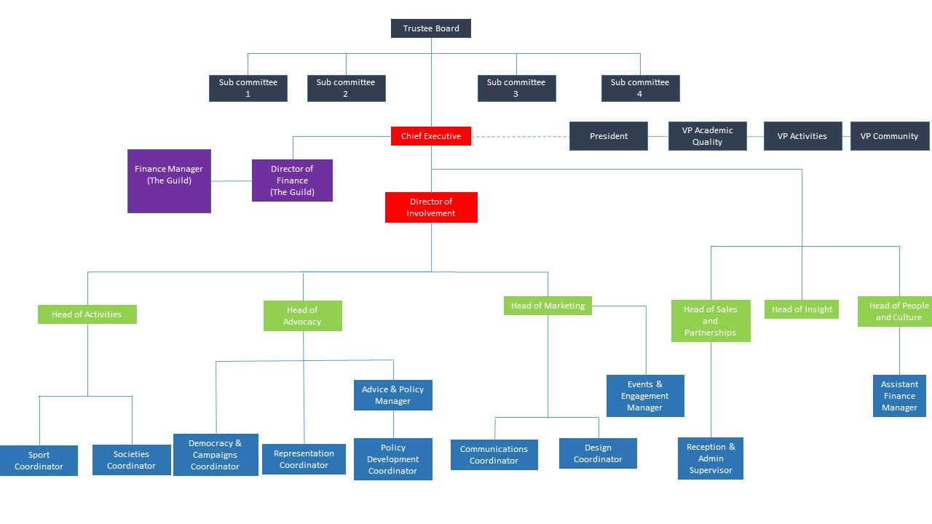

JOB DESCRIPTION

Job Title: | Democracy and Campaigns Coordinator
DEPARTMENT | Advocacy
REPORTING TO | Head of Advocacy
ROLE DESCRIPTION
The focus for the Democracy and Campaigns Coordinator is to ensure the work of the Union is student led. The role will take a lead in delivering support for our Full and Part Time Elected Representatives and relevant student volunteers to be effective in their roles and deliver campaigns. The role will work to develop the Union’s democratic practices through participation, consultation, deliberation and election.

Please read the candidate requirements below and ensure you demonstrate you possess the listed attributes in your written application and in person if you are shortlisted for interview.

JOB ROLE RESPONSIBILITIES

ESSENTIAL CRITERIA
- 1-2 years’ experience in a similar role
- Previous experience of volunteer management
- Previous experience of running campaigns
- Previous experience in a member led or third sector organization

KEY RESPONSIBLIITIES

Coordinate and develop the democratic and representation structures, as well as the change making processes of the Union; maximising levels of student participation and engagement and supporting activist development within them.

Support the shaping of policy through the democratic structures and its promotion to students

Develop a programme of ongoing support and training for elected representatives, which enables them to successfully deliver relevant objectives and policies across the year.

Support elected representatives to run a responsive, engaging and fair democratic process that seeks to involve students in decisions that affect them.

Briefing and debriefing the Student Officer team and relevant student reps, prior to and after university committees, as appropriate.

Work with elected representatives to promote and support liberation work and campaigns.

Work with colleagues, to ensure political campaigns and policy development are rooted in an evidence-based approach; and delivery and impact can be measured.

Develop and maintain political campaigning resources for use by elected representatives, students and relevant staff.

Work alongside the Head of Advocacy to provide administration and coordination support for the delivery of LiverpoolSU elections

To coordinate the Union’s representation at national conferences and events, including NUS activities and policy development.

Maintain a working knowledge of Union campaigns, past and present, and ensure Officers and relevant staff are aware of policy that relates to their role.

Keep up to date with developments in democracy and campaigns in the student movement and the wider third sector to inform the role and inform the development of the Union’s policy process, ensuring that elected representatives are well briefed.

Maintain an up-to-date knowledge of issues affecting the Higher Education and local agendas

Providing free and independent advice to students and being responsible for supporting LJMU students to report any hate crime, as appropriate.

Providing representation to students who are subject to formal panels or meetings, as appropriate.

To be responsible for monitoring student led democracy and campaigns budgets and escalating any financial issues to the Head of Advocacy.

Maintaining positive relationships and communication with other student unions and colleagues at Liverpool John Moores University.

Ensure all duties and actions comply with data protection and confidentiality policies.

Required to work unsociable hours on an ad-hoc basis to support Liverpool Student Union with events across the academic year.

Required to work at other social spaces within the Liverpool Student Union portfolio and external venues on an ad hoc basis to support various events.

On occasion, be willing to be flexible regarding the start and finish times to meet particular, foreseen or unforeseen work.

You will also be required to carry out any other duties that may reasonably be required of you.

FURTHER INFORMATION ON THE ROLE

Salary: | £20,561-£24,558 per annum
Hours of work: | This is a full time role working 35 hours per week however as a family friendly organization, we will consider part-time, job-share or other flexible working patterns.
Office Location: | Liverpool Students' Union  John Foster Building  Mount Pleasant  Liverpool, L3 5UZ  .
Line Manager: | Becci McEvoy, Head of Advocacy.

HOW TO APPLY

Applications should consist of:

- A completed application form, please note this is instead of a CV to help us obtain the specific information we need, CVs will not be considered.
- An equal opportunities monitoring form.

Applications should be emailed to LiverpoolSU Reception who will anonymise them and pass them onto the recruitment panel:

Reception: studentsunion@ljmu.ac.uk

THE APPLICATION TIMELINE

Stage 1: Applications are submitted and considered by our recruitment panel.
Stage 2: Shortlisted candidates are interviewed.
Stage 3: The successful candidate is appointed.

Application Closing date:
Friday 7th September, 2018

WHO TO CONTACT

Queries regarding the job description:

Head of Advocacy
Email: b.mcevoy@ljmu.ac.uk
Phone: 0151 231 4900

Queries regarding the progression of your application:

Reception
Email: studentsunion@ljmu.ac.uk
Phone: 0151 231 4900
Address: John Foster Building, Mount Pleasant, Liverpool, L3 5UZ

